Software Requirements Specification for Library Management System
Table of Contents:
1.0 Introduction
1.1 Purpose
1.2 Scope of Product
1.3 Definitions, Acronyms, and Abbreviations
1.4 References
1.5 Overview
2.0 General Description
2.1 Product Perspective
2.2 Product Functions
2.3 User Characteristics
- 2.4 General Constraints
- 2.5 Assumptions and Dependencies
- 3.0 Specific Requirements
- 3.1 Functional Requirements
- 3.1.1 User Interface
- 3.1.1.1 Library user account manage system
- 3.1.1.2 Book borrowing system
- 3.1.1.3 Book recall system
- 3.1.1.4 Search book record
- 3.1.2 Data Entry
- 3.1.2.1 Library user account manage system
- 3.1.2.2 Book borrowing system
- 3.1.2.3 Book recall system
- 3.1.2.4 Search book record
- 3.1.2.5 Update book database
- 3.1.3 Report Generation
- 3.2 Performance Requirements
- 3.3 Design Constraints
- 3.4 Security Requirements
- 3.5 Reliability
  - Introduction
  - Purpose
- This is the Software Requirements Specification (SRS) for the Library Management System. The purpose of this document is to convey information about the application's requirements, both functional and non-functional, to the reader. This document provides (a) a description of the environment in which the application is expected to operate, (b) a definition of the application's capabilities, and (c) a specification of the application's functional and nonfunctional requirements.
The document is intended to serve several groups of audiences:
- First, it is anticipated that the SRS will be used by the application designers. Designers will use the information recorded here as the basis for
- creating the application's design.
- Second, the client for the project, the library manager in our case, is expected to review this document. The SRS will serve to establish a basis
- for agreement between the client and development team about the functionality to be provided by the application.
- Third, the application maintainers will review the document to clarity their understanding of what the application does.
- Fourth, test planners will use this document to derive test plans and test cases.
- Finally, the project manager will use this document during project planning and monitoring

1.2 Scope of Product
- The purpose of this software development project is to create a new application called: Library Management System. The client for this project wishes to enter the PC-based LAN environment. The Library Management System will be PC-base with a LAN, allowing library users to search for books and library staff members to manage the book inventory and user database. The application will provide the following capabilities:
- The application will be access via a LAN on a PC terminal in the Library
- Library staff will be able to manage library user accounts including remove, change, and add.
- Library staff will be able to manage the book inventory database including remove, change, and add.
- The application will record all books that are checked out, checked in, and recalled.
- The application will generate reports for administrative purposes.
- The application will provide search function on books based on ISBN, subject, title, or author.
The project's client has determined that this application will provide the following benefits:
- Provide additional flexibility and convenience to the library users.
- Provide better reliability and security of the library information.
- Provide a more productive environment for the library staff member.
- Reduce the cost of the library operations.

1.3 Definitions, Acronyms, and Abbreviations
- SRS - Software Requirements Specification.
- PC - Personal Computer.
- LAN - Local Area Network.
- IEEE - Institute of Electrical and Electronics Engineers.
- ISBN - International Standardized Bin Number.

1.4 References
Merlin Dorfman, Richard H. Thayer, "Standards, Guidelines, and Examples on System and software Requirements Engineering", IEEE, 1990.

1.5 Overview
A brief description of the content of each chapter is given below.
- 1.0 Introduction
- Provides an overview of the project. Summarizes the major capabilities of the product.

• 2.0 General Description
• Presents the environment in which the application is expected to operate, provides an overview of the system requirements, describes assumptions about possible users of the application, possible constraints on the project, and the underlying assumptions that on which the requirements analysis is based.

• 3.0 Specific Requirements
• The specification of requirements. Contains a complete description of the application's requirements, both functional and non-functional.
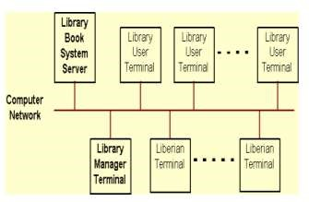
2.2 Product Functions
The high level summary of functions in Library Book System is described in the following concept map. Detail functional requirements will be described in section 3
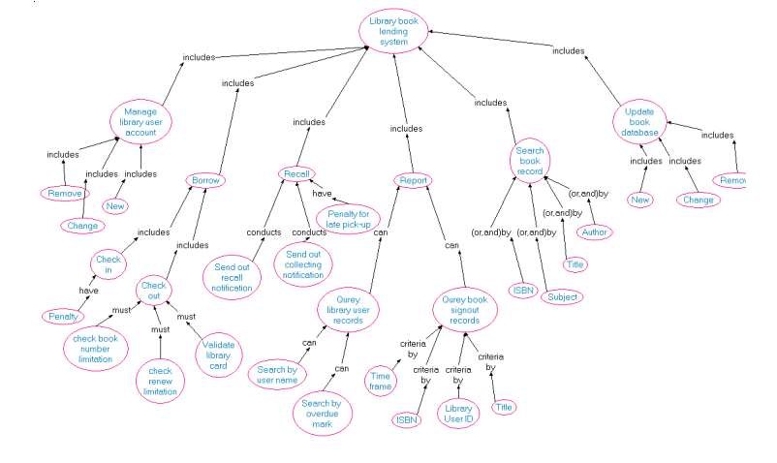
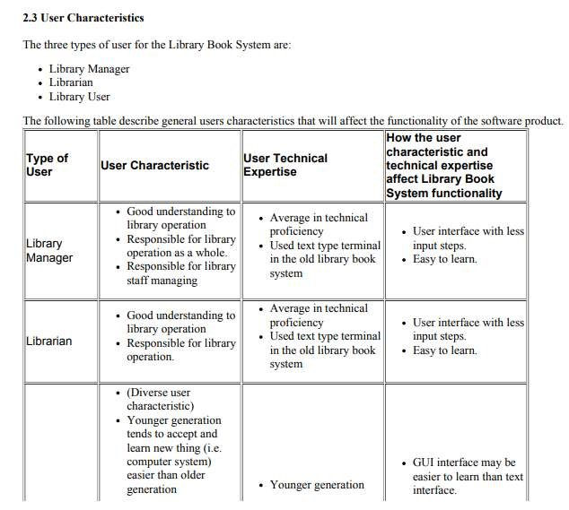
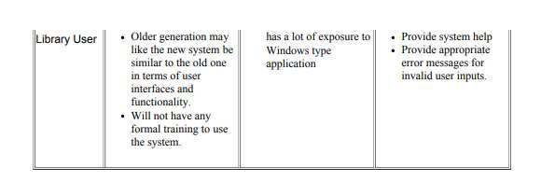

2.4 General Constraints
The current hardware for the existing Library Book System is mainframe with text type terminal. Therefore, if the new system is PC based, there will be a need to replace with PC hardware and new network facility. The Library Book System can potentially have hundreds of users. It is unrealistic to provide training for everyone. Therefore, the system should be designed for easy to use, providing help instructions, and appropriate error messages for invalid user inputs. Security is important to library operation. Library user is allowed to use the Library Book System only for searching book records. User should never be able to break into the system and to perform any modification.
Reliability is vital to library operation.
2.5 Assumptions and Dependencies
The following is a list of assumptions and dependencies that would affect the software requirements if they turned out to be false:
# Users have basic understanding to PC and Windows.
# There is a method to convert all book records and library user records from the existing system into the Library Book System.
3.0 Specific Requirements:
This section contains the detailed requirements. In this section, the users of "Search Book Record" are refereed to librarians and patrons (library users). Users of other sections are only refereed to the librarian card holder (librarians and library managers.)
3.1 Functional Requirements

3.1.1 User Interface
The user interface requirements are concerned with the user interface and how information is presented to the user.

• 3.1.1.1 Library user account manage system
- SRS-001: The system shall display the user account information including user ID, last and first name, and user position, privilege.
- SRS-002: The system shall use a graphic user interface which allows librarians to choice actions including removing, changing and adding user account and account information..
- 3.1.1.2 Book borrowing system.
- SRS-003: When check out the books, the system shall show all the book borrowing information about a particular user including:
- the first and last name of the user
- the library card number
- the library card expiring date
- if the user has unpaid penalty
- the number of books the user has not return
- SRS-004: When check out the books, when required by librarians, the system shall show the information about books which is borrowed before and not returned yet including: • the ISBN of the book
- the title of the book
- the borrowing and due date of the book
- the branch which the book is checked out
- SRS-005: When check out the books, the system shall display the information of the book which is just being checking out including:
- ISBN, title, due date.
- SRS-006: When check in the books, the system shall show the title, ISBN of the book which is being checked in. When check in is finished, a "check in" stamp shall be seen.

• 3.1.1.3 Book recall system
- SRS-007: When recalling the book, the system shall display a list of all the copies of the book which is borrowed out ordered by book lend out time.
- SRS-008: When the recalled book is arrived, the system shall display the last and first name, the recall date and the arriving date of the book. If only one copy of book is arrived and more than one user are waiting, users shall be displayed ordered by recalling time. When check in recall book is finished, a "check in recall" stamp shall be seen.

• 3.1.1.4 Search book record
- SRS-009: The system shall display a list of books which are match the search criteria sorted by book titles including:
- the category
- the ISBN
- the title the author
- SRS-008: When required by users, the system shall display the information about a particular book including:
- the category
- the title
- the ISBN the publisher
- the brief description of the book (if any stored in database) • the location in library
- 3.1.2 Data Entry The data entry requirements are concerned with how data is entered and validated.
- SRS-010: The system shall allow a user to enter his/her data via a keyboard or choose an item via a mouse.
- SRS-011: Whenever the "date" data is needed, it shall be entered only by choose date from a online calendar.
- SRS-012: The system shall allow the user to enter the library card number and ISBN both by typing or scanning.
- SRS-013: The system shall allow the user to enter book borrowing, recalling data as frequently as required.
- 3.1.2.1 Library user account manage system
- SRS-014: The system shall allow the user to attach notes to each account
- SRS-015: The system shall allow the user to add or change information in an account including: last name, first name, user ID, user position, user privilege.
- SRS-016: the system shall allow the user to delete an entire account.
- 3.1.2.2 Book borrowing system.
- SRS-017: The system shall allow the user to specify a checking out book using its ISBN.
- SRS-018: The system shall allow the user to specify a patron by the library card number.
- SRS-019: The system shall allow the user to specify a checking in book using its ISBN.
- SRS-020: The system shall allow the user to specify that a penalty is paid.
- SRS-021: The system shall check and show the number of books which are checked out and if the number is exceeded the limitation for patrons except for librarian card holders.
- SRS-022: The system shall check and show if the book can only be used in library SRS-023: The system shall let the librarian card holders to check out books which can only be used in library.
- SRS-024: The system shall commit the check in and check out data to the database as soon as the data is entered.

• 3.1.2.3 Book recall system
- SRS-025: The system shall allow the user to specify a recalled book by book ISBN
- SRS-026: The system shall allow the user to choose one copy of book to recall from a list of copies which are borrowed out
- SRS-027: The system shall allow the user to record the record notification send out date, the book arrive date, the pick-up notification send out date.

• 3.5 Reliability
- SRS-041: The system shall be recovered within 10 minutes if it is down
- . SRS-042: The system shall be recovered without intervention at user terminal if it is down. SRS-043: The system shall show appropriate messages at terminal when system is down.
- SRS-044: The system shall have 99% reliability during library operating hours.
- SRS-045: Scheduled down time after library operating hours shall not be more than 1 hour per day.
- SRS-046: The system shall generate error messages when the user attempts to enter invalid data.

DONE BY
PARVATHA SRINI.KP (111723203070)
NETHIYa sree.m (111723203066)
Laksita.m (111723203052)
Priyajothi.n (111723203076) Poojitha.n (111723203071)
thank you…..

